Graph Theory - I

1. | Consider the following everyday morning activities:  ➔ Waking Up  ➔ Brushing  ➔ Leaving the house  ➔ Taking a shower  ➔ Getting dressed  ➔ Having breakfast  Constraints:  - You must not get dressed before taking a shower  - You are free to have breakfast and then brush, or the opposite  - After waking up: you can either take a shower and then brush, or the opposite  - You must not leave the house without getting dressed  - Waking up is the first thing you do, and leaving the house is the last activity  - Draw a directed graph representing the activities as nodes, and constraints as edges.  - From the above activities, write two different topologically sorted sequences of  activities.  - Explain in short, how you would use DFS to topologically sort the activities.
2. | The following information is stored after implementing the DFS algorithm on an undirected graph.  - Draw the DFS tree.  - Fill up the empty rows of the table.
  Nodes | 1 | 2 | 3 | 4 | 5 | 6 | 7
  Parent
  Starting Time | 8 | 11 | 5 | 6 | 4 | 1 | 2
  Finish Time | 9 | 12 | 10 | 7 | 13 | 14 | 3
  Distance from Root
3. | A software build system manages modules {1, 2, 3, 4, 5, 6, 7} where a directed edge u→v means module u must be compiled before module v. The dependency graph G has been provided below:  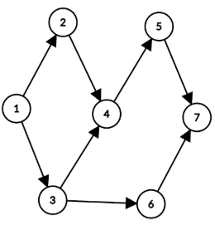  - Simulate DFS on G starting from module 1, visiting neighbors in numerical order (whenever there is a tie). Record discovery time d[v] and finish time f[v] for each module.  - A valid compilation order requires every module to appear after all its dependencies. Using the finish times from Q(a), determine one such order.  - A developer adds a new dependency 7→3, forming graph G'. Identify all cycles from G'. Just write your answer, no need to show any simulation.  - Since G' contains cycles, a topological sort no longer exists. To fix the build order, merge all mutually dependent modules that form cycles into a single node. Modules not in any cycle remain as individual nodes. Using the cycles from Q(c), list the members of each merged group and draw the resulting dependency graph.
4. | Consider the directed graph given below.  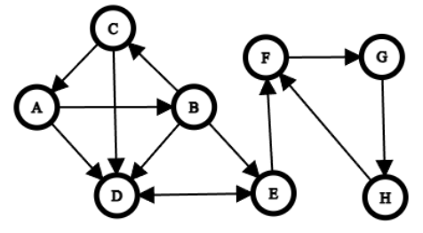  - Find out the minimum number of edges to remove from the graph, so that there exists a topological order among the vertices. Explain your reasoning.  - Using an appropriate algorithm, identify all strongly connected components (SCCs). Then, treat each SCC as a single vertex, draw the resulting graph, and determine whether any cycles remain
5. | - For a directed graph, does the number of back edges equal the number of cycles present?  Explain briefly  - Given a directed graph G = (V, E) represented with an adjacency list, explain how you can find whether the graph is a directed acyclic graph (DAG) or not. Your method must be as asymptotically efficient as possible.  - Given a set of SCCs, what is the maximum number of new SCCs that can appear if we delete one edge from the DAG of these SCCs?

